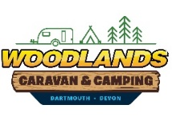
Woodlands’ Rally Information Form 2021

Rally Name: Organiser: Rally Dates:

Booking Number: Date Form Received by Woodlands’ Office:

 | Name | Type of Unit i.e. Tent, Caravan, Motorhome, Trailer Tent | Size of Unit  (lengths of Caravans & Motorhomes, widths & lengths of Tents, in meters) | Electric Hook-up  YES/NO | Number of Adults  Number of Children  (list separately) | Gazebo/Awning  YES/NO | Pup Tent  YES/NO | Dog  YES/NO
1
2
3
4
5
6
7
8
9
10
11
12
13
14
15
16
17
18
19
20

